GUI Development Individual Assignment

02-Mar-02

GUI Development

Michealin White (20063529)

Lecturer David Drohan

# Introduction

In this assignment I was to create Android application that would be able to add and list a movie. I decided to create a Movie app that would display details about a movie. I made the Buttons large and easy to see and read and very basic input and edit. You might need to install Youtube on the device to play the trailer for the movie depending on the device. You also need internet access to play the video.

# Main Functionality

The Main functions include being able to add a movie, view, search for a movie by movie title, delete a movie and edit movie details.



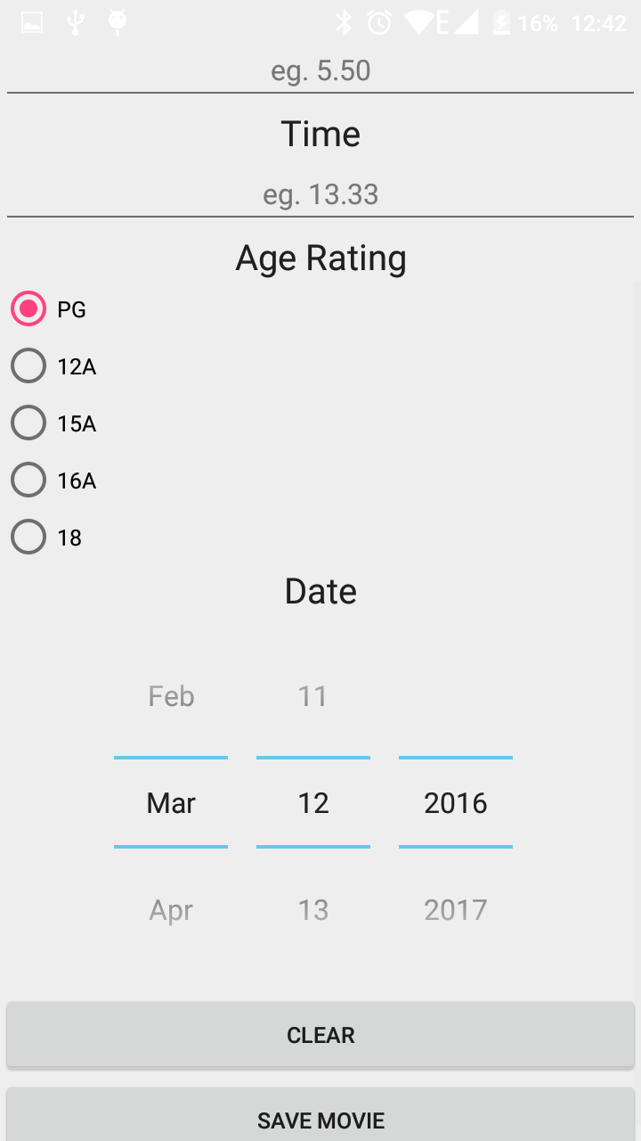

# Extra Functionality

The extra functionality I included was the datePicker to pick the date when the movie is playing. I used SQLiteDatabase to save movie details.

I created a filter by function which allows users to filter by movie Title, movie ID, movie time and cinema this filter is done by using SQLiteDatabase and the ORDER BY function. 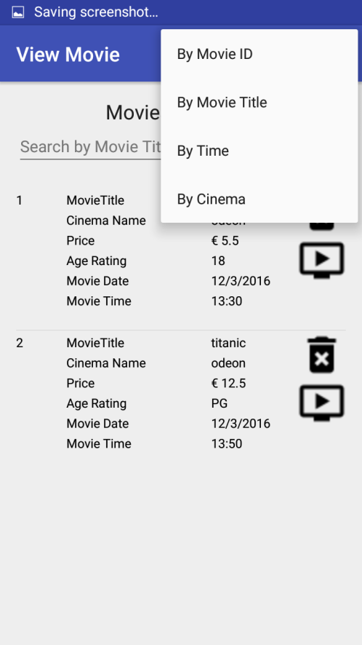

I also implemented a Youtube player functionally so users can view the trailer of the movie the entered. I did this by getting the name of the movie the user entered and searches it using the API and retrieves the video which is then used to play the video.



# References

<http://developer.android.com/guide/topics/ui/dialogs.html>

<http://www.codeproject.com/Articles/783073/A-Simple-Android-SQLite-Example>

<http://stackoverflow.com/questions/23762231/how-to-disable-past-dates-in-android-date-picker>

<http://stackoverflow.com/questions/2808535/round-a-double-to-2-decimal-places>

<http://www.joe0.com/2016/03/05/youtube-data-api-v3-how-to-search-youtube-using-java-and-extract-video-id-of-the-most-relevant-result/>

<https://ddrohan.gitbooks.io/android-101-labs-as/content/session4/lab/md/step04.html>

<https://developers.google.com/youtube/v3/docs/search/list#parameters>

https://www.youtube.com/watch?v=a4NT5iBFuZs

http://stackoverflow.com/questions/13136539/caused-by-android-os-networkonmainthreadexception